Component 1: Checklist

Student Name/ID: C7202804

Development Choice: PHPStorm / XAMPP

Add Screenshots to show successful setup – project window should show supplied case study

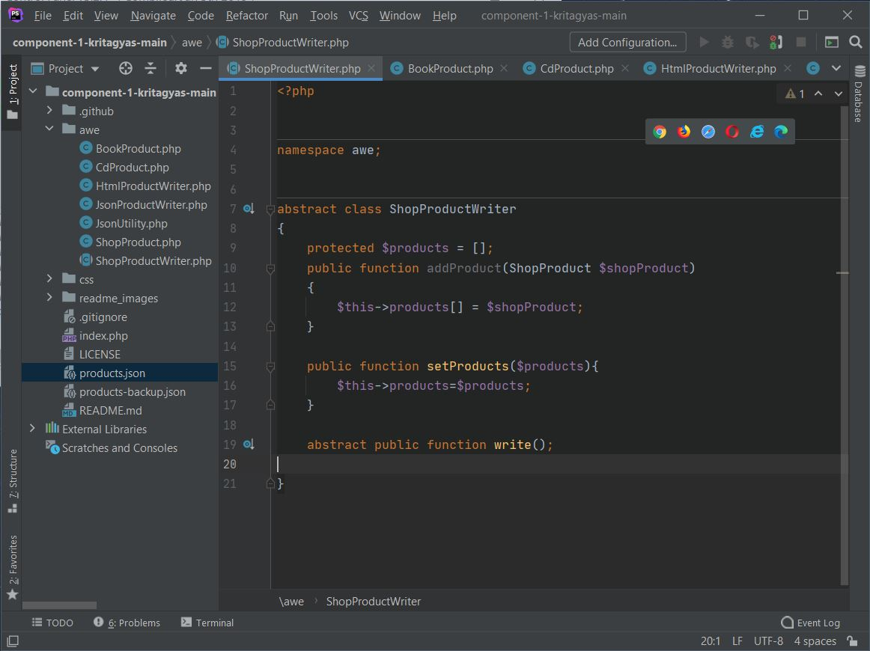

PHP Version being used: ‘7.4.11’ (3 marks)

XDebug installed: Yes

(add screenshot of output of php –v)
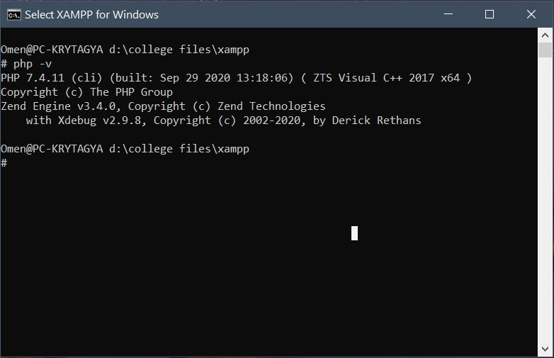

(2 marks)

Git account created and used: ‘ https://github.com/kritagyas/component1.git ’
(2 marks)

Remaining marks are awarded for completion of the short PHP exercise
(3 marks)

